1. Make sure that whether Eclipse IDE installed or not.

2. Double Click on the Eclipse Icon.

3. Launch the Eclipse By choosing “Workspace folder”. The Projects are stored in that folder.

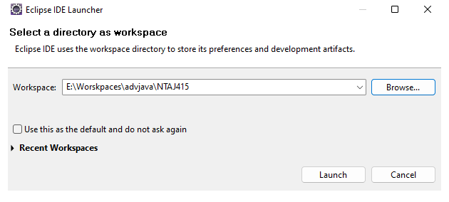

4. Create a Java project Name in Eclipse IDE.

File🡪 new 🡪 project🡪 java🡪 javaProject

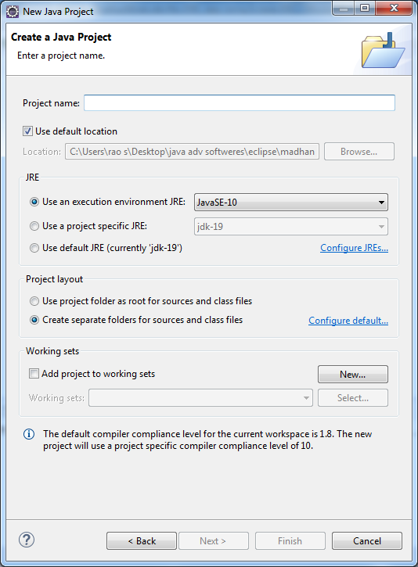

5. Enter the project name and click on Finish button.

6. Add ojdbc6/7/8/9 .jar file to Build-path of project.

Right click on project🡪build-path🡪configure build path

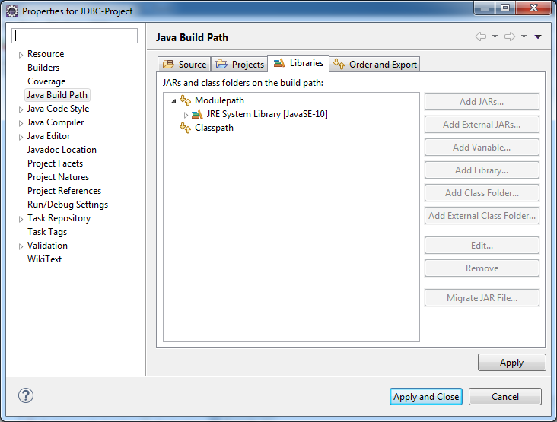

Click on Libraries Tab.

7. select Classpath

8. click on Add External Jars button.

Add the ojdbc6/7/8/9.jar file

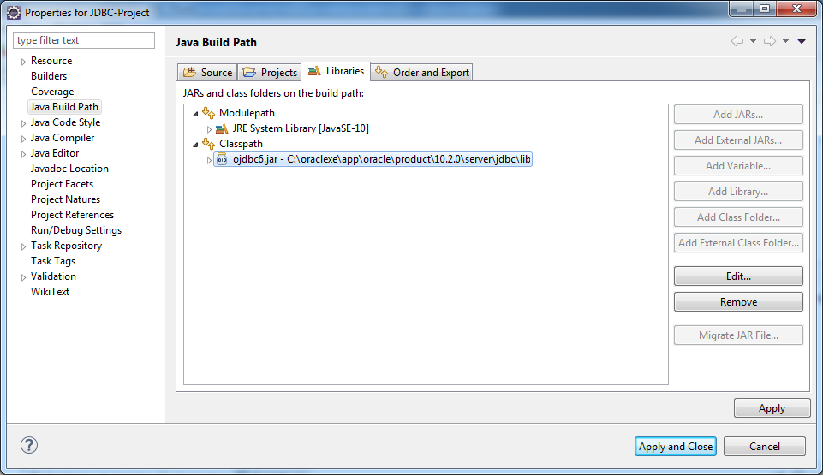

and click the apply and close button.

9. Create the package under the src.

Projectname🡪src

Right click on src 🡪 new 🡪 package

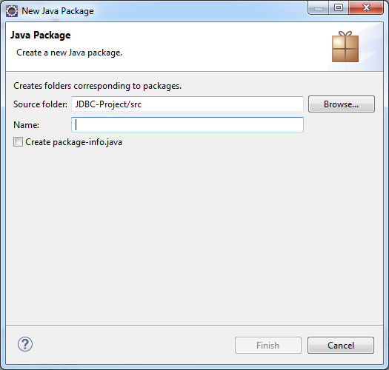

Enter the package Name and click on filnish button.

10. Add .java file to created package.

Right click on packageName🡪 new 🡪class

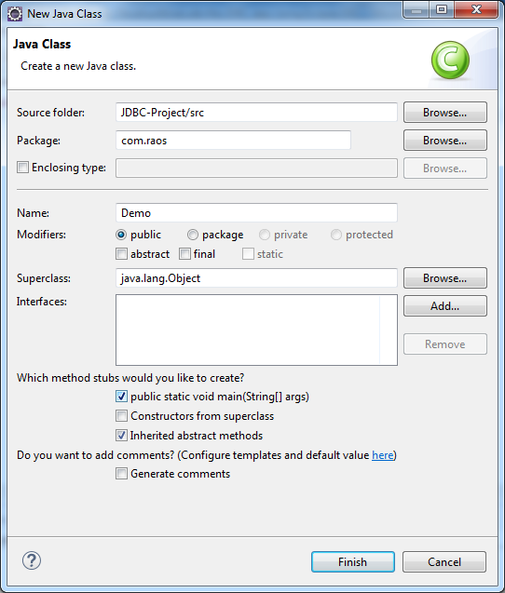

Enter the className and Press the finish button.

11. Write the logic.

12. Run the Application

Way1:- Press f11 button.

Way2:- Use Run button in the menu bar.

Way3:- rightclick on java file

Run As🡪 java app